Common Software Errors and Solutions

**Batch Processor:**

Error 7 occurred at list folder in batch processor.

Solution: Open windows explorer. Is there a red X on the waveforms server? If yes, double click it to reconnect.

**BigAccDAQ:**

Error -89125: No registered trigger lines….

Solution: Open NIMAX. Look at the Devices and Interfaces dropdown. If the Chassis is listed as “Unidentified PXI Chassis” or something like that, right click it and identify it as a PXI 1042 (note, this is accurate as of Aug 2020. By the time you read this there may be a different chassis). It’ll likely lose the individual cards. Reset the chassis a few times until the cards pop back up. I’m unfortunately not sure what I clicked on that finally got it to work, as it did so suddenly, but I believe it was just a reset that eventually worked.

If the chassis is correctly identified, make sure the individual cards are correctly identified. As of Aug 2020, it looks like this:

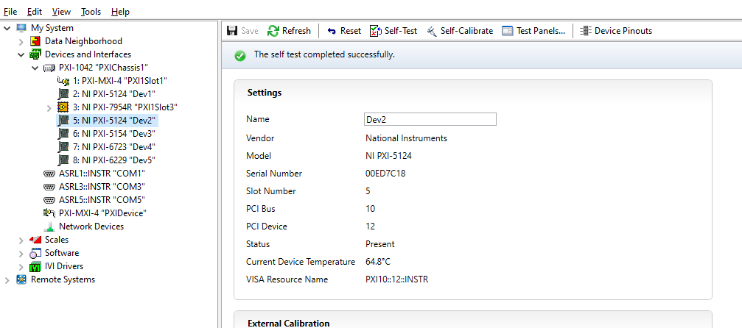

Database Connection:

Crashes immediately upon opening. “Access violation” in the body of the error message.

Solution: This is caused by rampant misuse of global and local variables, thus creating race conditions. To solve, try opening Query Dust Event by itself. This will open database connections with much less dependence on global/local variables. Once it’s opened and successfully pulls data from the database (once the plot window is populated), you can open Database Connection. Once that’s connected to the database (once the experiment settings, dust settings, dust operator, etc. populate), you can close Query Dust Event if you want.

If Query Dust Event also crashes with Access Violations, reboot. If problems persist, run the database_connection_test.vi in Accelerator/Database IO/ a few times. If no errors show up in the error indicator, try Query Dust Event again. If errors show up in the test vi, you’ve other problems. Are you connected to waveforms? Can you ping 192.168.1.102? Does MySQL Workbench successfully talk to the database? Is dusty’s IP address 192.168.1.105?